SIH 2026 · PS 26069 — National Weather Big Data Analytics Platform.
01 · CORE VISION
01 The What & Why
The problem
- Weather reports are scattered across Twitter, Telegram, WhatsApp — no unified view for authorities
- Old/duplicate photos get recirculated as "happening now" — no way to tell real from fake quickly
- IMD's own sensor network is authoritative but has real coverage gaps (NE, hill states, central India)
The solution
Weatherly collects citizen & social reports, cross-verifies each against real IMD/satellite data and other independent reports, and shows the result as a live, trust-scored map — turning smartphones into a supplementary observation layer that densifies IMD's network without overclaiming certainty.
Who it's for
Tier | Who | Needs
Primary | IMD, NDMA, district authorities | Trustworthy operational view, evidence-backed alerts
Primary | Citizen reporters | Easy low-bandwidth reporting (web + WhatsApp)
Secondary | Analysts / reviewers | Review queue with full evidence trail
Secondary | General public | Privacy-safe public map they can trust
Tertiary | Researchers, planners | Exportable historical event data

02 · FUNCTIONAL REQUIREMENTS
02 What It Must Do
Core features
- Citizen report submission — web form + WhatsApp, with map location confirmation
- Automatic event classification (flood, heatwave, storm, fog, dust, wind) from text & speech
- Location extraction cascade: GPS → profile → text NER → speech-to-text → clustering
- Duplicate detection — reposted media grouped as one evidence item, never double-counted
- Cross-check against IMD radar/AWS/satellite, with distance & time penalties
- Four-status trust output, human review queue for anything uncertain
- Public dashboard (masked data) + authority dashboard (full data, incident queue)
- Cluster-based alert escalation, human-approved before anything high-impact fires
⛔ Explicitly out of scope (this version)
- Live Twitter/X & Instagram ingestion (paid/restricted — sample data used instead)
- Full Kafka/Spark/Elasticsearch deployment (documented as scale architecture, not built)
- Native mobile app, full multilingual support beyond Hindi/English MVP
- Weather forecasting, public emergency broadcast authority, hardware/IoT deployment
- Legal/forensic evidence chain, automatic public accusation of individuals

03 · SYSTEM ARCHITECTURE & TECH STACK
03 How It's Built
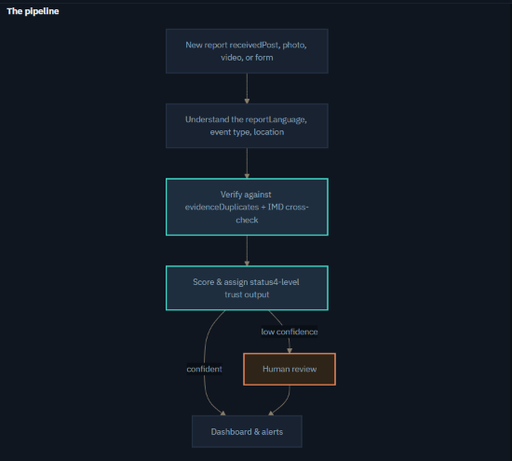
The pipeline

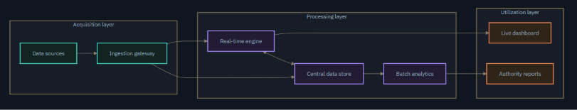
Three-layer system view

Tech stack
Layer | MVP choice | Documented for scale (not built now)
Frontend | React + Leaflet + Chart.js | —
Backend | FastAPI | —
Database | PostgreSQL + PostGIS | Elasticsearch (fast search at scale)
Ingestion | Direct write / light queue | Apache Kafka
Batch processing | — | Apache Spark
NLP / speech | IndicBERT / XLM-R, Whisper | —
Media storage | Local / cloud bucket | S3 / MinIO at scale

Agent architecture — a deliberate decision
The core verification pipeline is not an LLM agent — it's a deterministic ML + rule pipeline, chosen for explainability and auditability. The one optional LLM component is a goal-based Authority Query Assistant (retrieval-first, draft-only, never auto-sends) — no multi-agent framework, since the added complexity isn't justified here.
04 · RULES OF ENGAGEMENT
04 SOPs & Guardrails
The four verification statuses
Verified
Likely genuine
Unverified
Flagged
Key SOPs
01 Ingestion
Validate required fields, check consent, enforce file limits, store raw data first, then queue for processing.

02 Authentication
JWT + RBAC per role (citizen / analyst / authority / researcher); secrets never hardcoded; rate-limited APIs.

03 Error handling
Source down → cached/replay data + visible banner, never silent staleness. Processing failure → retry, then human queue.

04 Human review
Low-confidence/flagged reports queued by severity; every reviewer action logged with identity + timestamp.

05 Data retention
Personal data masked by default, time-bound retention, deletion requests actionable, access logged (DPDP-aligned).

⛔ The AI is forbidden from
- Asserting hard certainty — never "this is fake," only "flagged, manipulation suspected" + evidence
- Treating missing evidence as a negative signal — absence of data ≠ proof nothing happened
- Publicly naming or accusing a specific citizen of posting fake content
- Letting one report trigger a high-impact alert — requires corroborated cluster + human approval
- Forcing a label when confidence is low — must abstain and route to a human instead
- Down-ranking a report just because it's in a less-supported language/dialect

